Bampton and District Local History Society members’ meetings
The Lost Boy
Author John Little relates the story of Thomas Martindale, the 9 year old boy who left Bampton and got lost on the fells in 1907. John has walked the route that he believes that Tommy followed and what he probably did next…

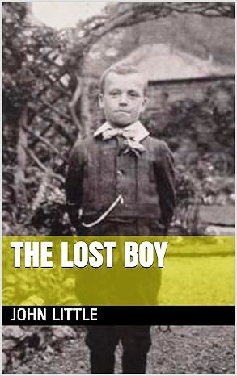

Annual General Meeting
Tuesday 1st October
7:30pm
Bampton Memorial Hall

Everyone welcome!
Refreshments will be served
Members £1 Visitors £3

